*****ONLINE SHOPPING CART***



***DESIGNED & DEVELOPED BY***

STUDENT ID 1284681: Syed Muhammad anus

STUDENT ID 1237748: Wajahat Iqbal

STUDENT ID 1278713: Syed Mubeen Hussain

STUDENT ID 1282540: Aryan mustafa

***TABLE OF CONTENTS***

Certificate of completion ........................................ 4

Acknowledge................................................... 5

Preface ........................................................6

Introduction…………………………………… 7

So what is E-project………………………….8

Objective of the project…………………9

Problems Statement ................................. 10

Hardware and Software Requirements ..................... 11

Data base diagram…………………………….12

Home page…………………………………….13

About us page……………………………..14

Shop page…………………………………15

Product page…………………………………..16

Contact us page……………………………..25

Below Rs 99 product ………………………………26

FAQ page………………………………………….31

Home registration……………………………………32

Login page…………………………………………..33

Admin login……………………………………………..34

Add to cart……………………………………………….35

Checkout…………………………………………………..36

User profile page……………………………………………37

Order page……………………………………………………39

Order notification page……………………………………….40

Admin dashboard……………………………………………….41

Category page…………………………………………………..42

Product page……………………………………………………43

Add customer page……………………………………………44

Add employee page………………………………………….. 45

Admin order page……………………………………………. 46

Order return page……………………………………………..47

Product comment page………………………………………..48

Admin registration page………………………………………..49

Admin logout page………………………………………………50

***CERTIFICATE OF COMPLETION***

This is to certify that Syed Muhammad Anus, Wajahat Iqbal, Syed Mubeen Hussain, Aryan Mustafa has successfully completed their ACCP Semester 3 E-Project.

Submitted to: **Aptech Metro Star Gate Center**

On

**August 7th, 2022**

***ACKNOWLEGDE***

We would like to thank All-Mighty ALLAH who gave us courage to succeed in completing the Third-semester I-Project. Moreover, we would like to thank our Parents and Family Members who appreciated our work and granted the permission to work on this project late night.

We would also like to thank our classmates and colleagues who shared their ideas and comments to make this project look better every time. The software used in development of the project is Visual Studio code and Date Base is created in Xampp control panel.

We were asked to make a user-friendly website on “Online Shopping Cart”. We earnestly hope that this project will provide all online products required for the user to fulfil their needs.

***PREFACE***

We are thankful to Allah that our I-Project has been accomplished.

We would like to dedicate this project to the Aptech faculty which is working diligently to ‘Unleash the Potential’ from their students and been always there for the help and support. Special thanks to our class-teacher Sir Ali Haider, who keeps us motivated and enthusiastic throughout the project, guided us regarding the project and helped us thoroughly.

We hope that our efforts would be appreciated with good sanctions.

*****INTRODUCTION***

The thirst for learning, upgrading technical skills and applying the concepts in real life environment at a fast pace is what the industry demands from IT professionals today. However busy work schedules, far-flung locations, unavailability of convenient time-slots pose as major barriers when it comes to applying the concepts into realism.  And hence the need to look out for alternative means of implementation in the form of laddered approach.

The above truly pose as constraints especially for our students too! With their busy schedules, it is indeed difficult for our students to keep up with the genuine and constant need for integrated application which can be seen live especially so in the field of IT education where technology can change on the spur of a moment. *Well, technology does come to our rescue at such times!!*

Keeping the above in mind and in tune with our constant endeavour to use Technology in our training model, we at Aptech have thought of revolutionizing the way our students learn and implement the concepts using tools themselves by providing a *live and synchronous eProject   learning environment!*

***So what is this eProject***

eProject is a step by step learning environment that closely simulates the classroom and Lab based learning environment into actual implementation. It is a project implementation at your fingertips!! An electronic, live juncture on the machine that allows you to

* Practice step by step i.e. laddered approach.
* Build a larger more robust application.
* Usage of certain utilities in applications designed by user.
* Single program to unified code leading to a complete application.
* Learn implementation of concepts in a phased manner.
* Enhance skills and add value.
* Work on real life projects.
* Give a real life scenario and help to create applications more complicated and useful.
* Mentoring through email support.

The students at the centre are expected to complete this eProject and send complete documentation with source code to eProjects Team.

Looking forward to a positive response from your end!!

***OBJECTIVE OF THE PROJECT***

The Objective of this program is to give a sample project to work on real life projects. These applications help you build a larger more robust application.

The objective is not to teach you concepts but to provide you with a real life scenario and help you create applications using the tools.

You can revise them before you start with the project.

It is very essential that a student has a clear understanding of the subject.

Kindly get back to eProjects Team in case of any doubts regarding the application or its objectives.

***PROBLEM STATEMENT***

Problem statement is attached separately in a file “**Online Shopping Cart**”

**Standards plan:**

Every code block must have comments.

The logic of the program needs to be explained. Proper documentation should be maintained.

Complete Project Report along with synopsis, code and documentation should be prepared.

**Documentation:**

No project is complete without documentation. In fact, it is one of the most important activities during the development of a project. The documentation of an ideal project will be in the form of a project report comprising of the following documents:

* Certificate of Completion.
* Table of Contents.
* Problem Definition.
* Customer Requirement Specification.
* Project Plan.
* E-R Diagrams.
* Algorithms.
* GUI Standards Document.
* Interface Design Document.
* Task Sheet.
* Project Review and Monitoring Report.
* Unit Testing Check List.
* Final Check List.

***Hardware/ Software Requirements***

**Hardware**

* A minimum computer system that will help you access all the tools in the courses is a Pentium 166 or better
* 128 Megabytes of RAM or better

**Operating System**

* LINUX / Windows 2000 Server (or higher if possible)

**Software**

* PHP
* MySQL
* PERL
* Apache

*****DATABASE DIAGRAM***

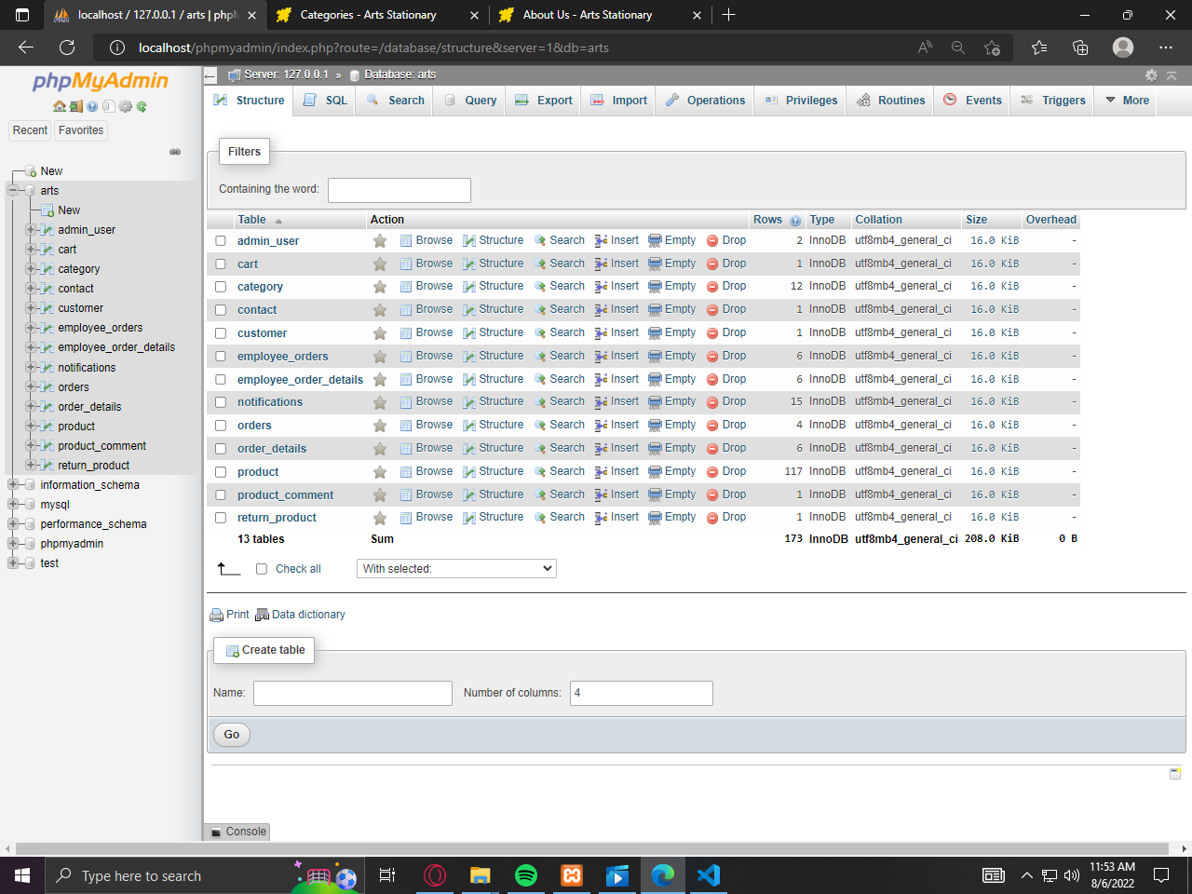

***SCREEN SHOTS***

***HOME PAGE***

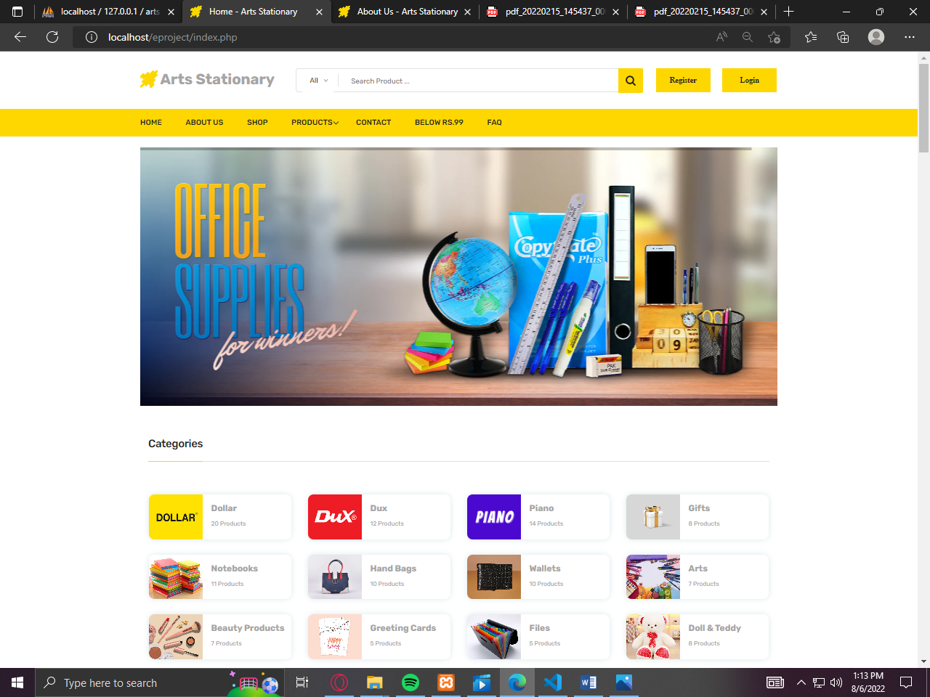

***ABOUT US***

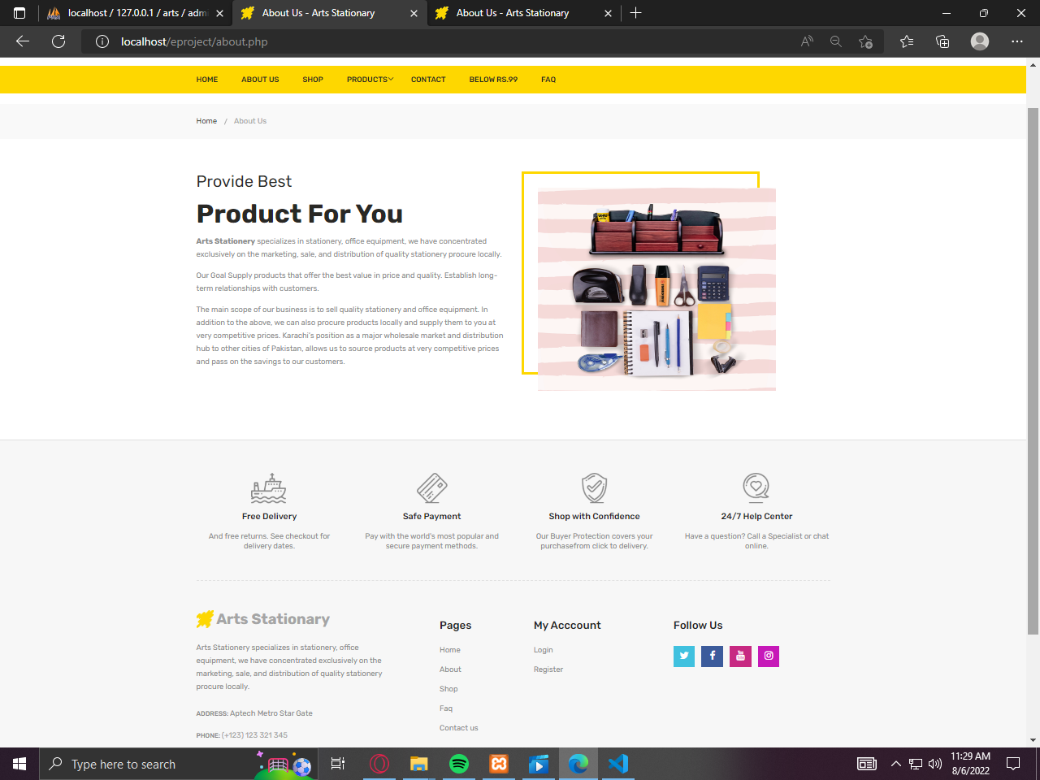

***SHOP PAGE***

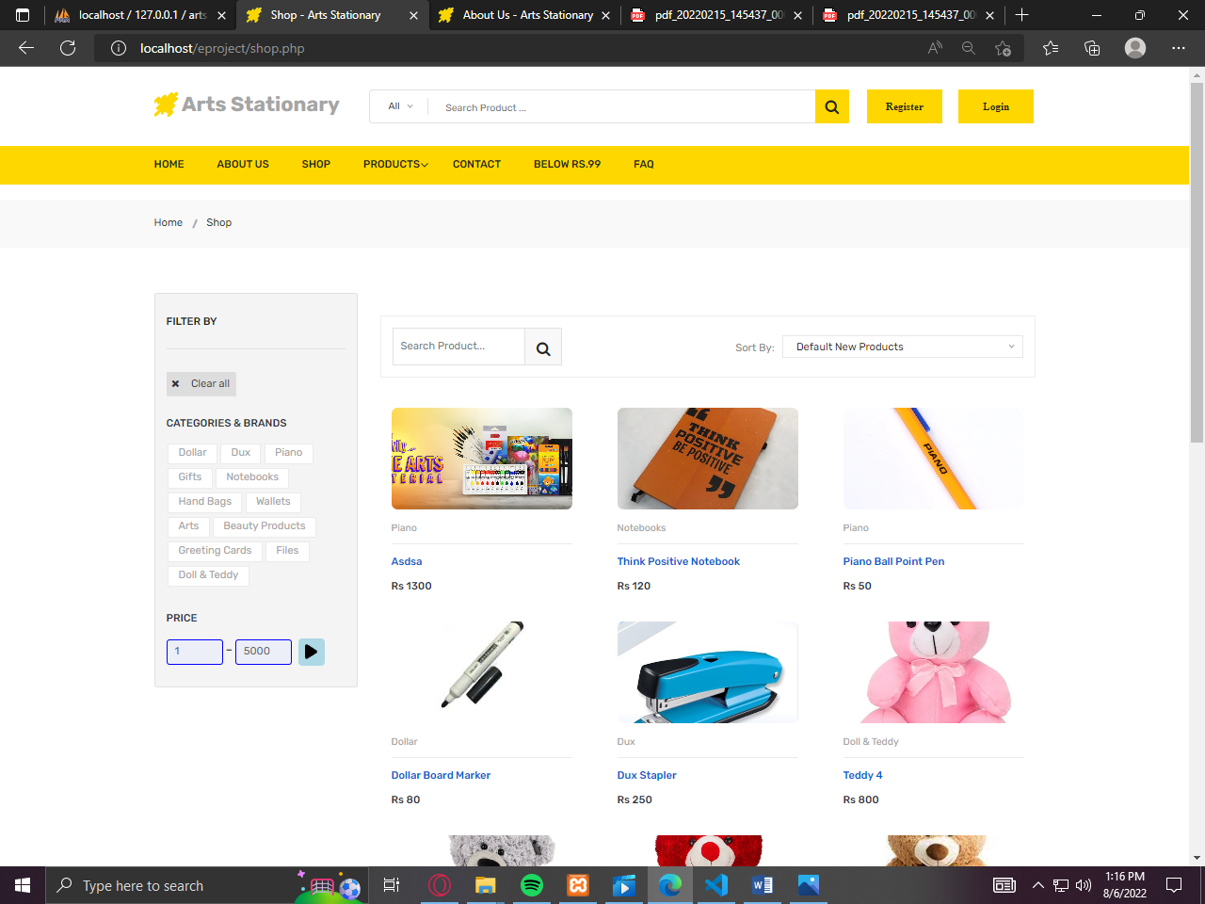

***PRODUCT PAGES***

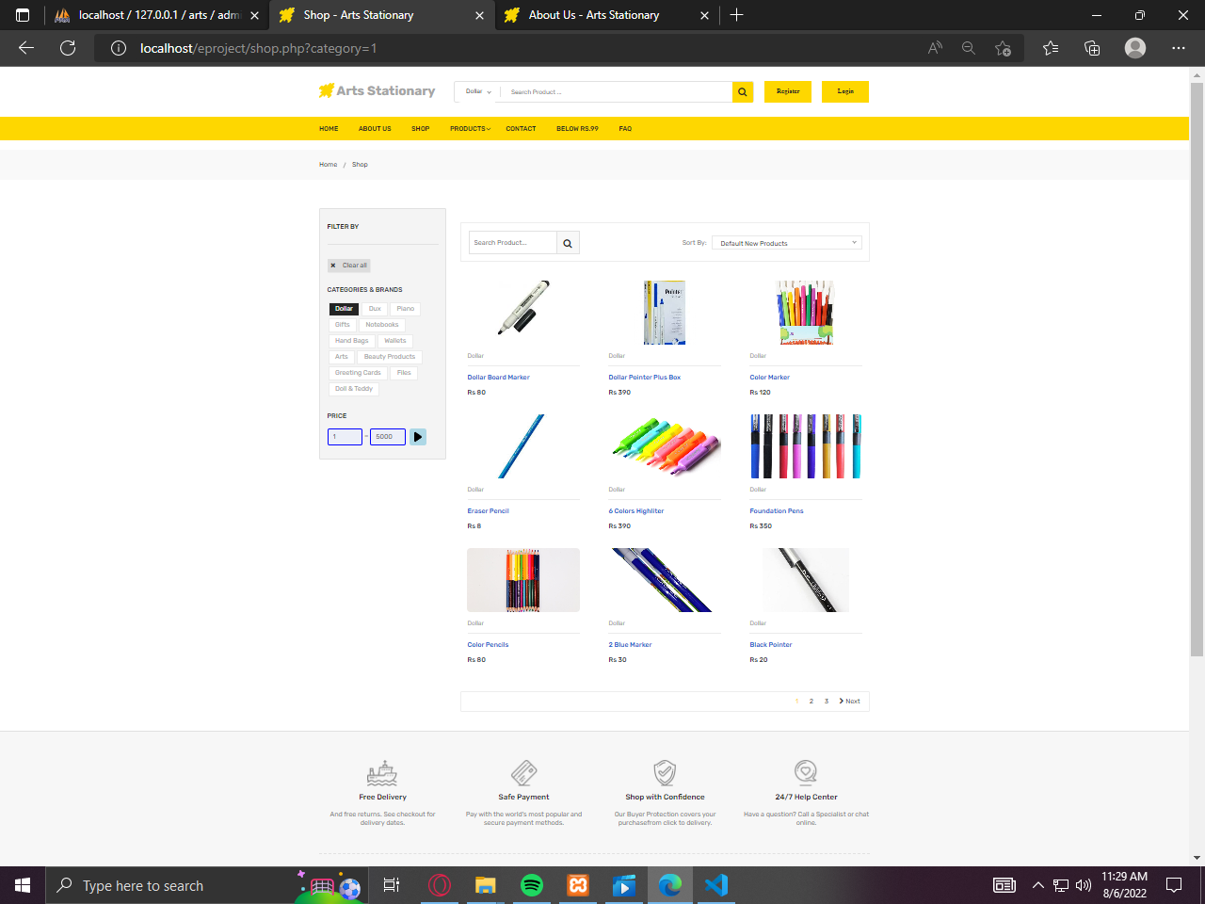

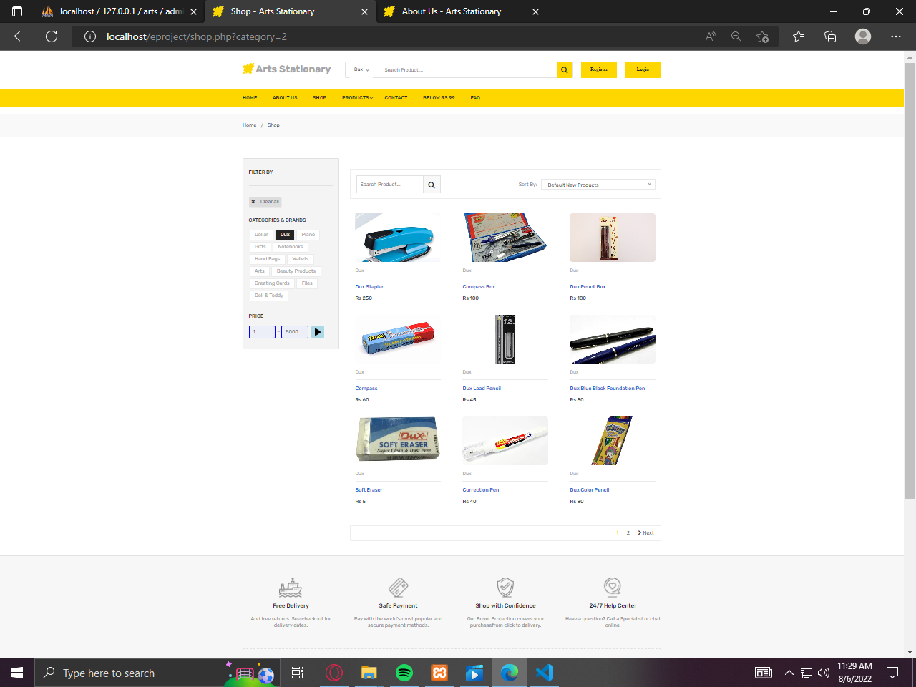

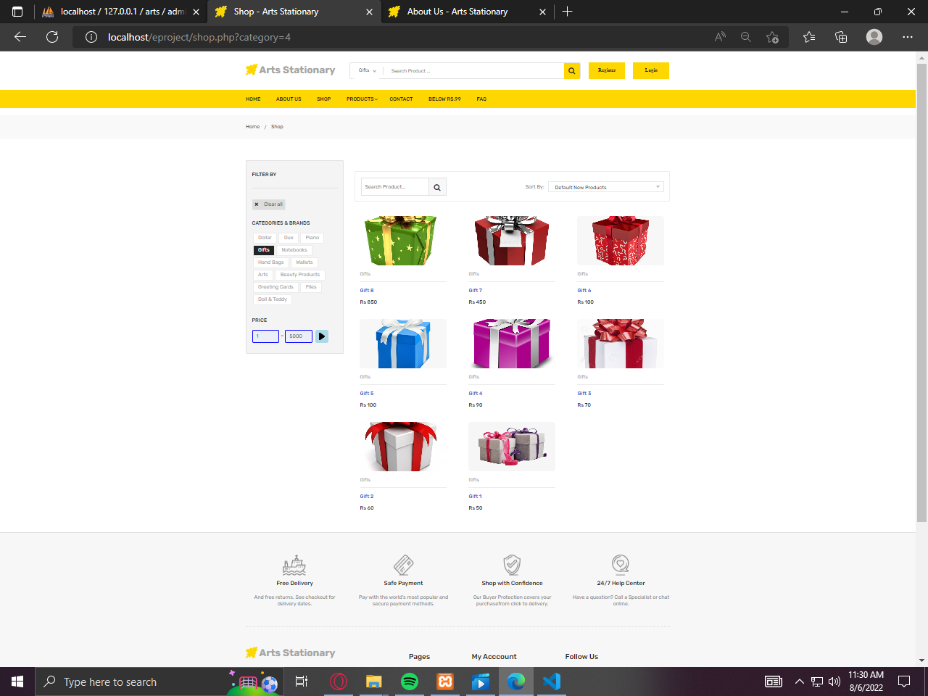

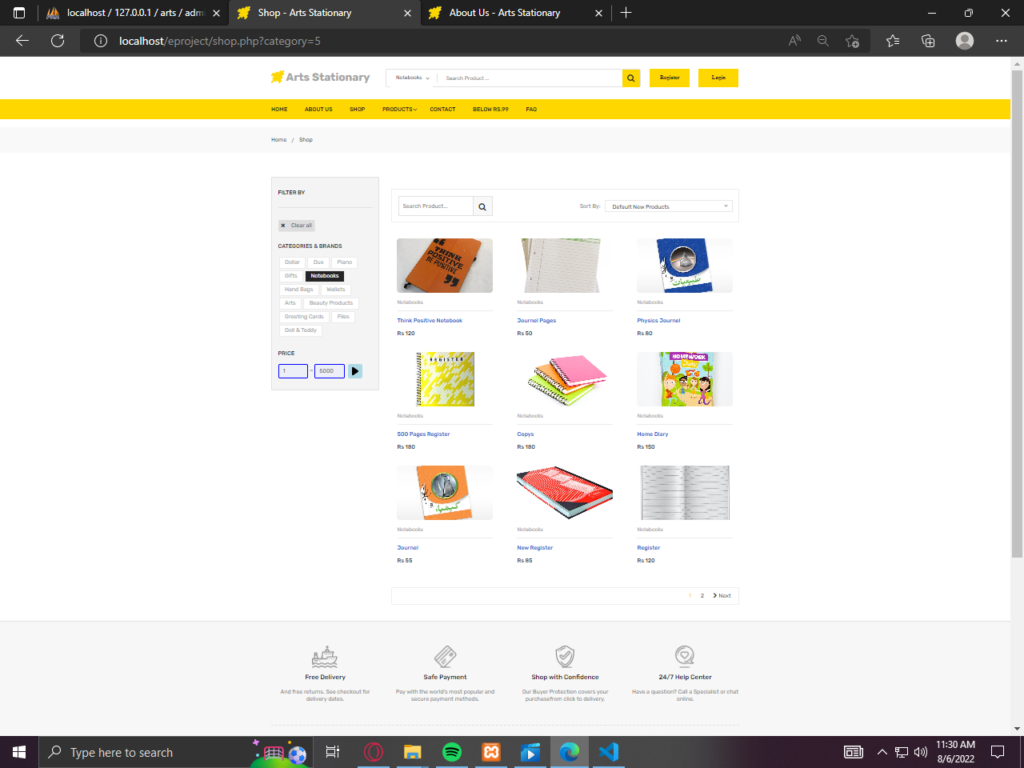

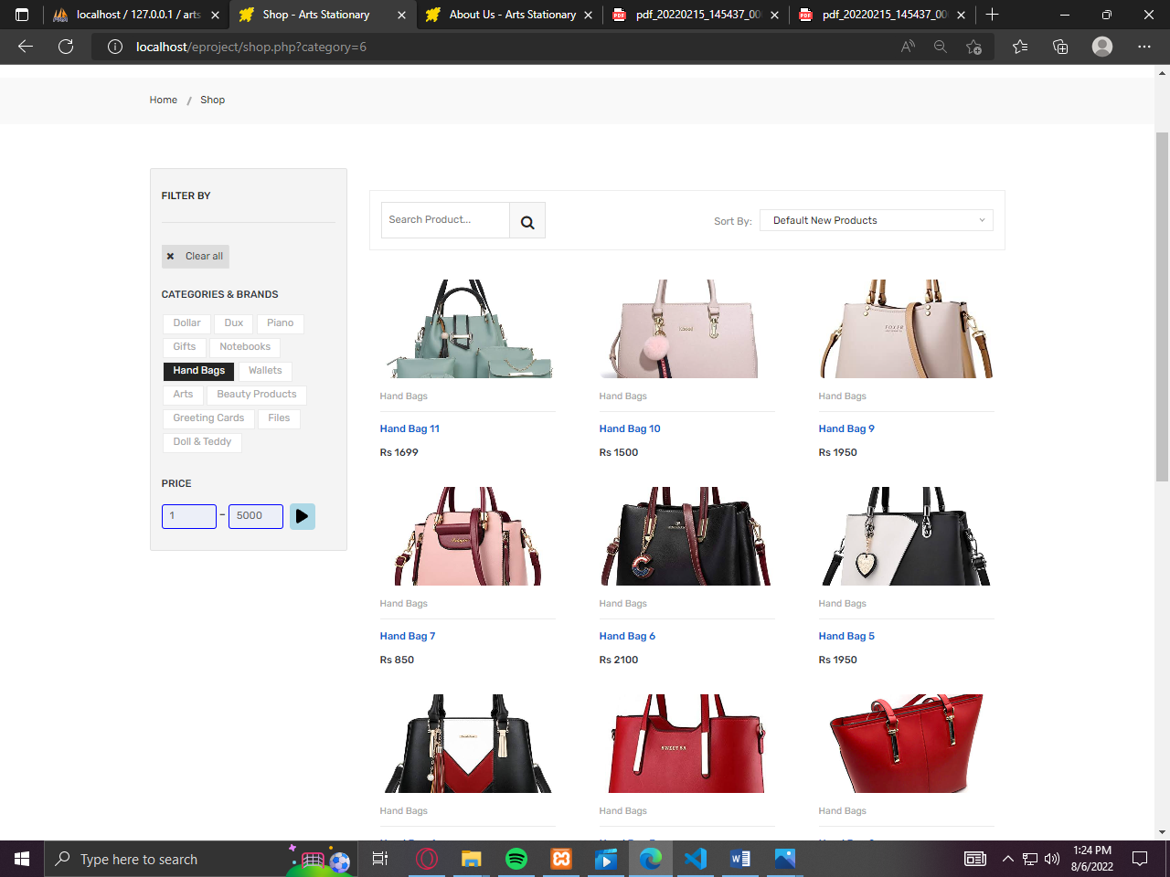

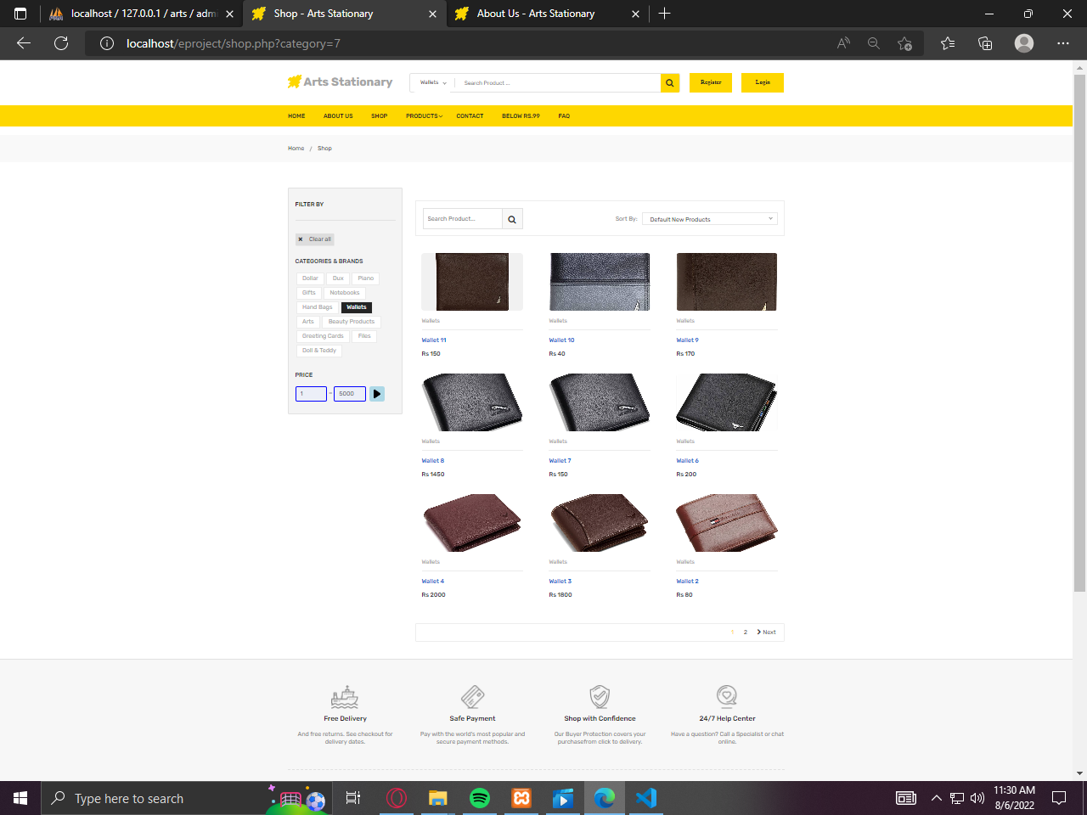

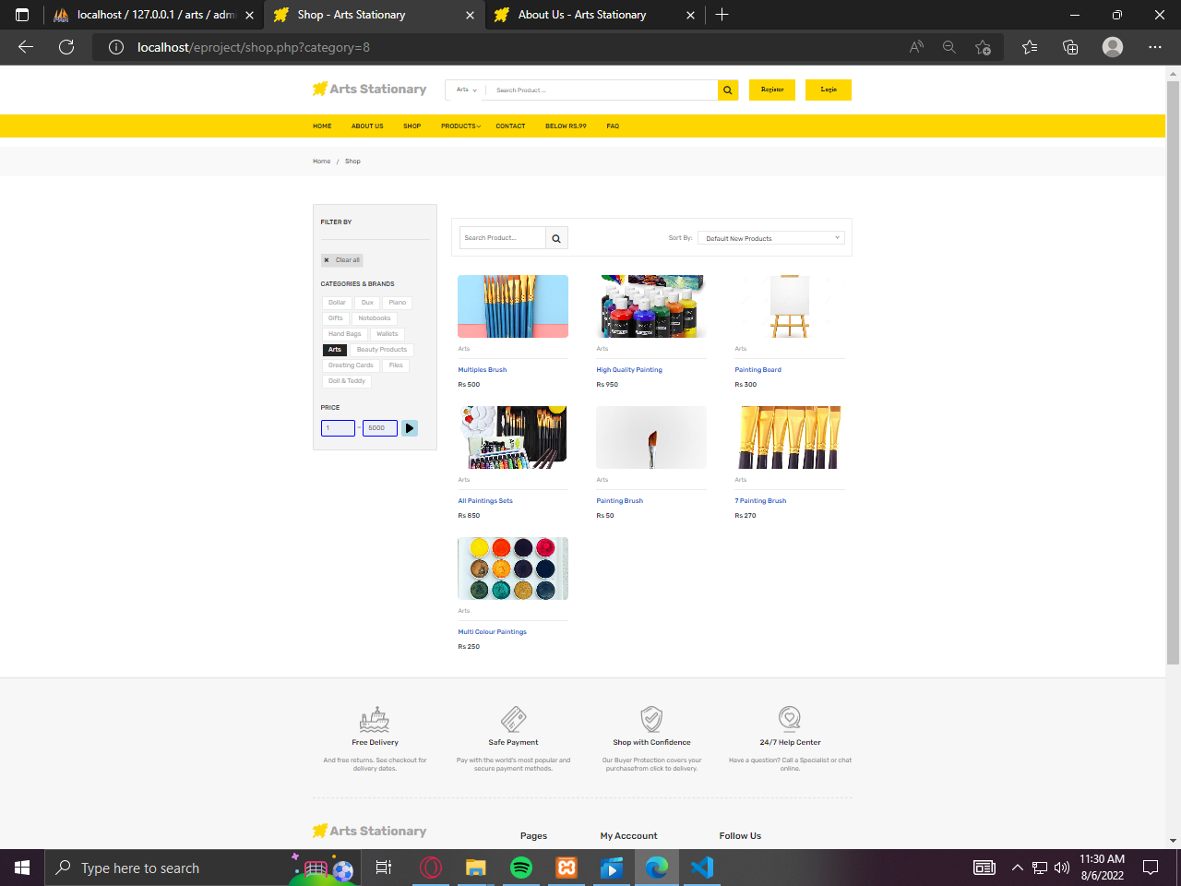

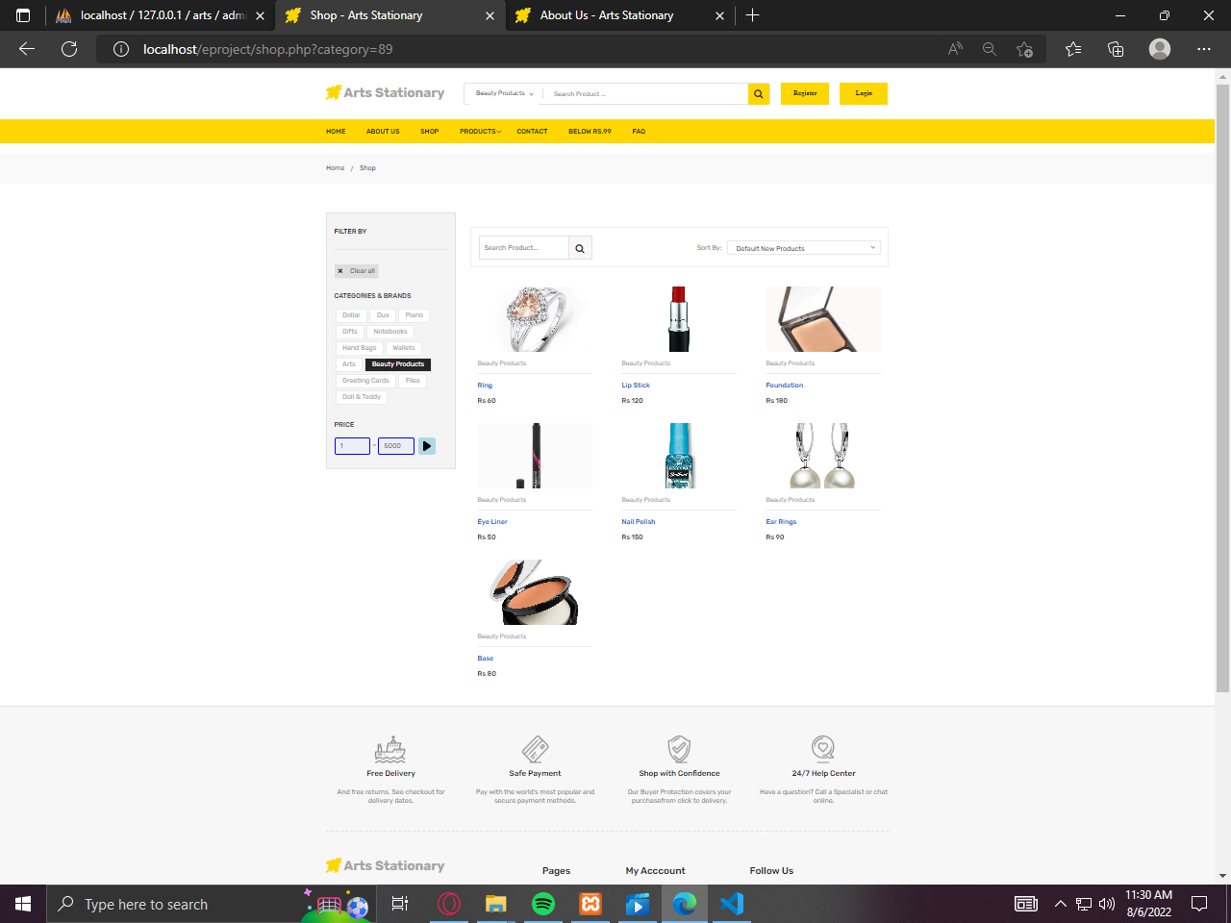

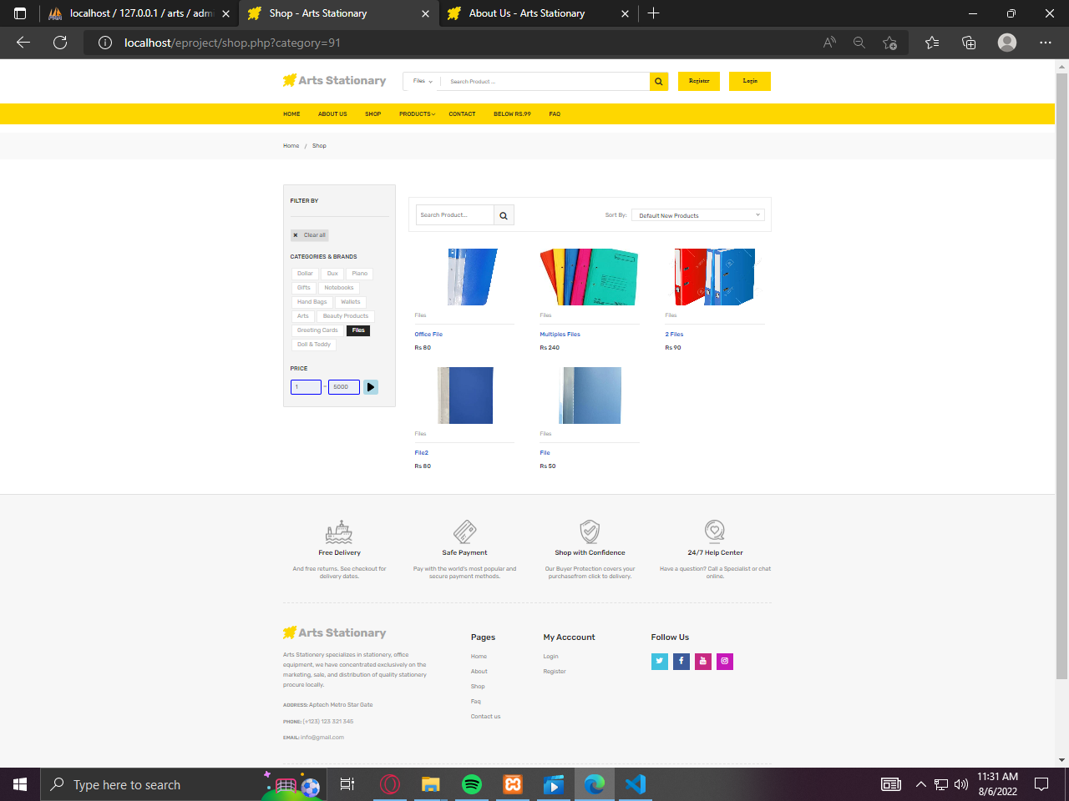

*****CONTACT US PAGE***

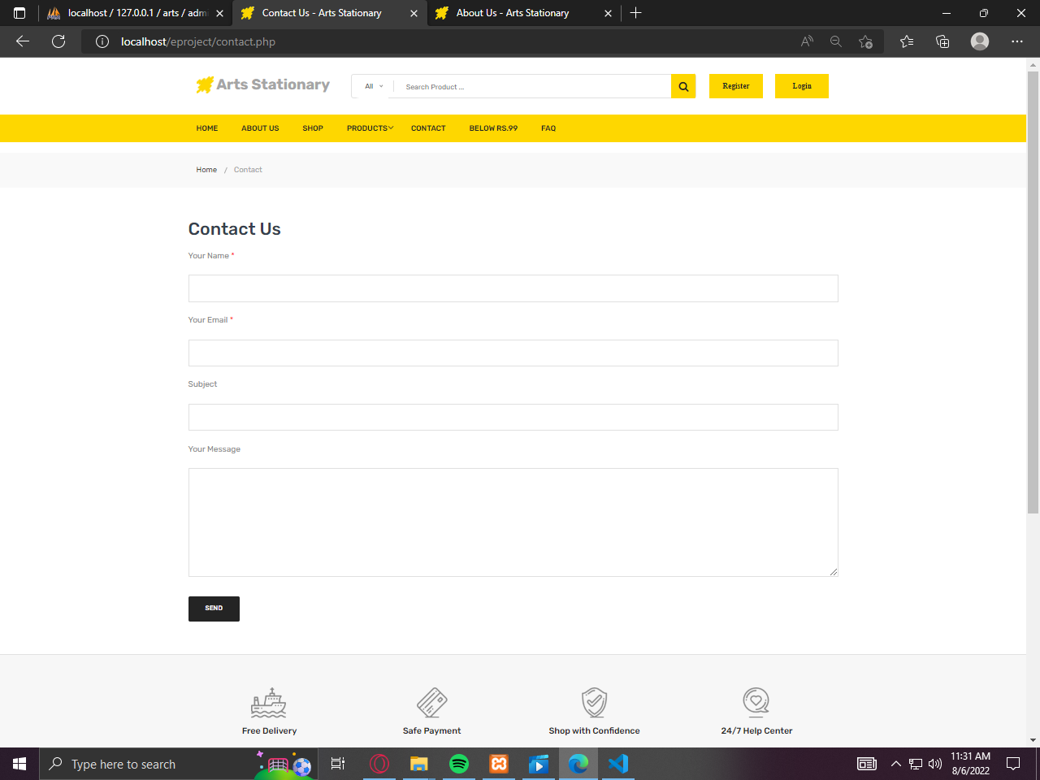

***BELOW RS99 PRODUCTS***

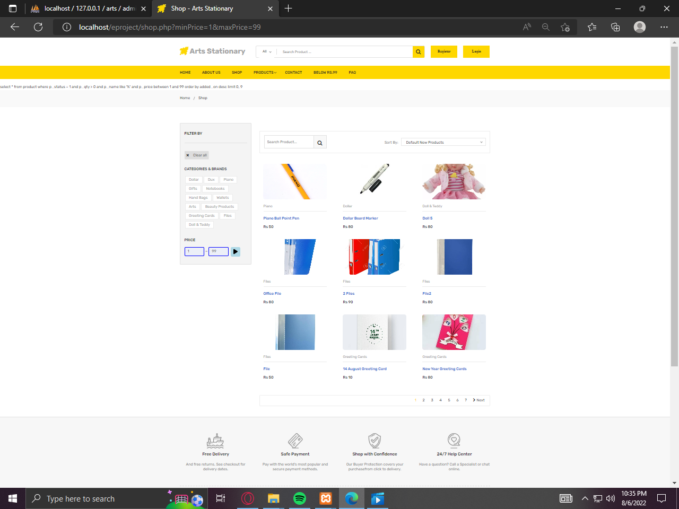

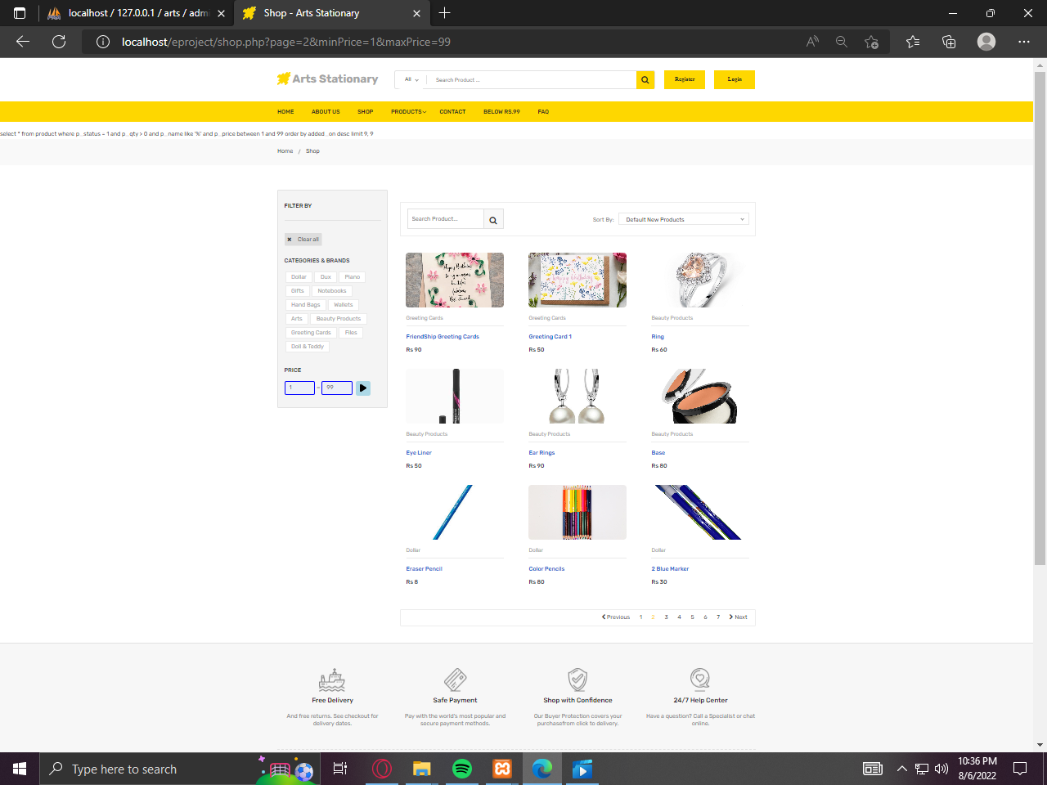

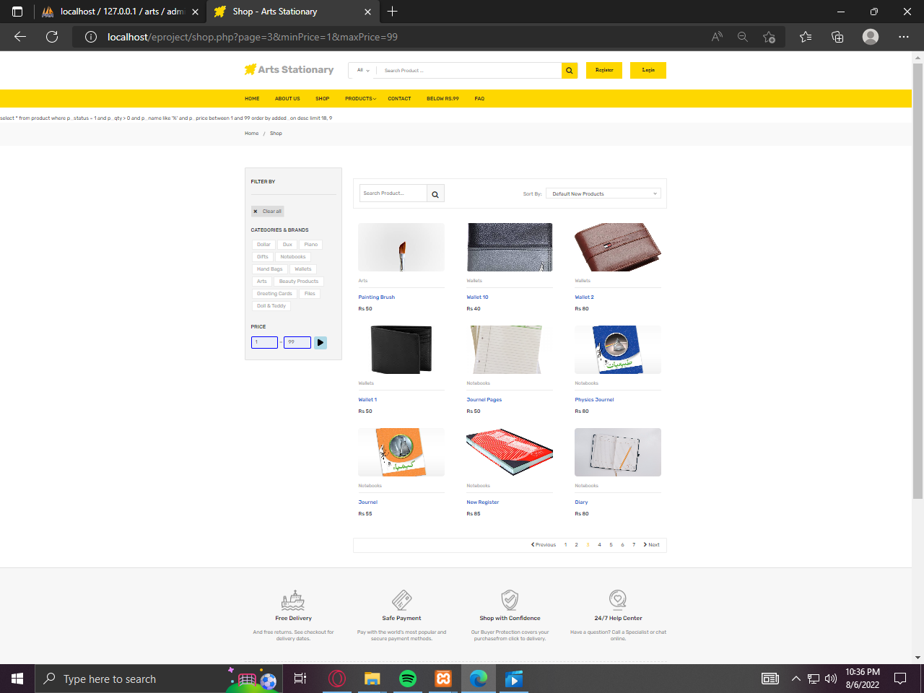

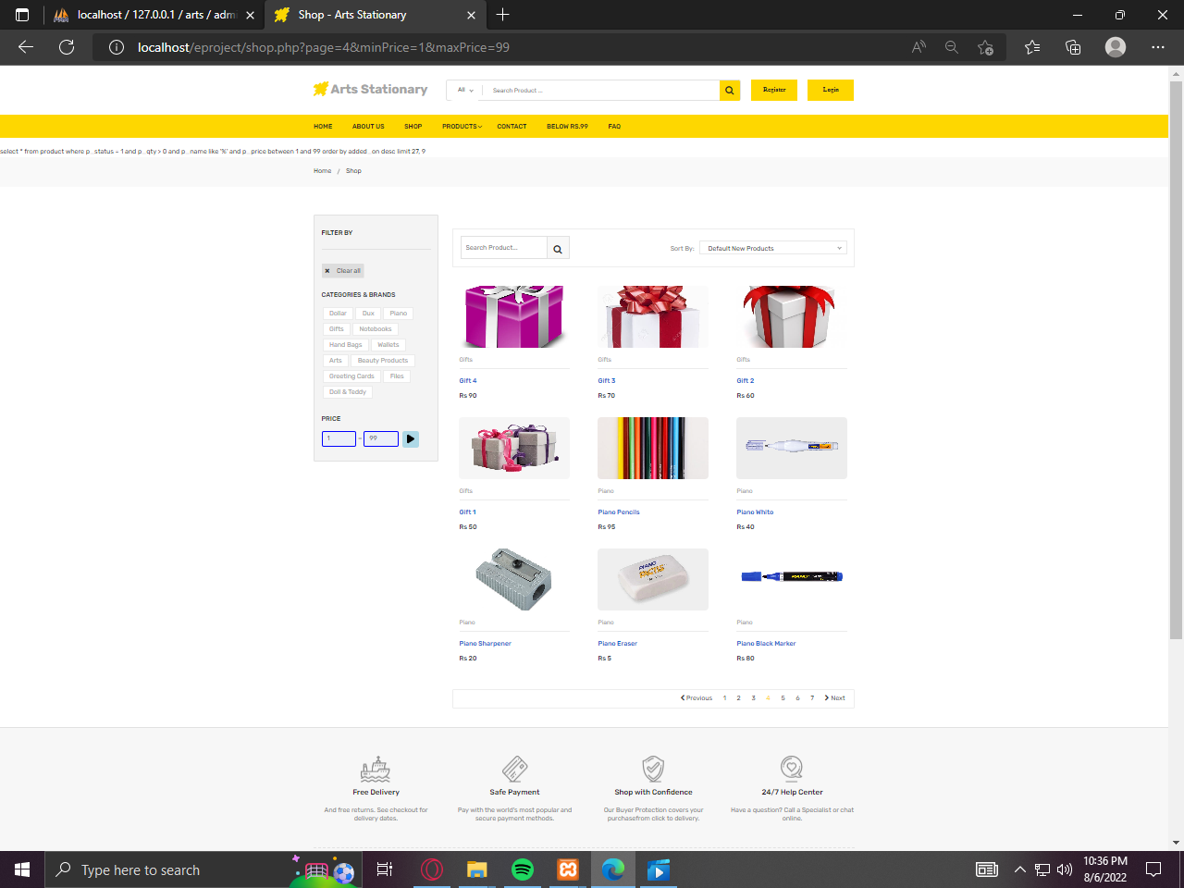

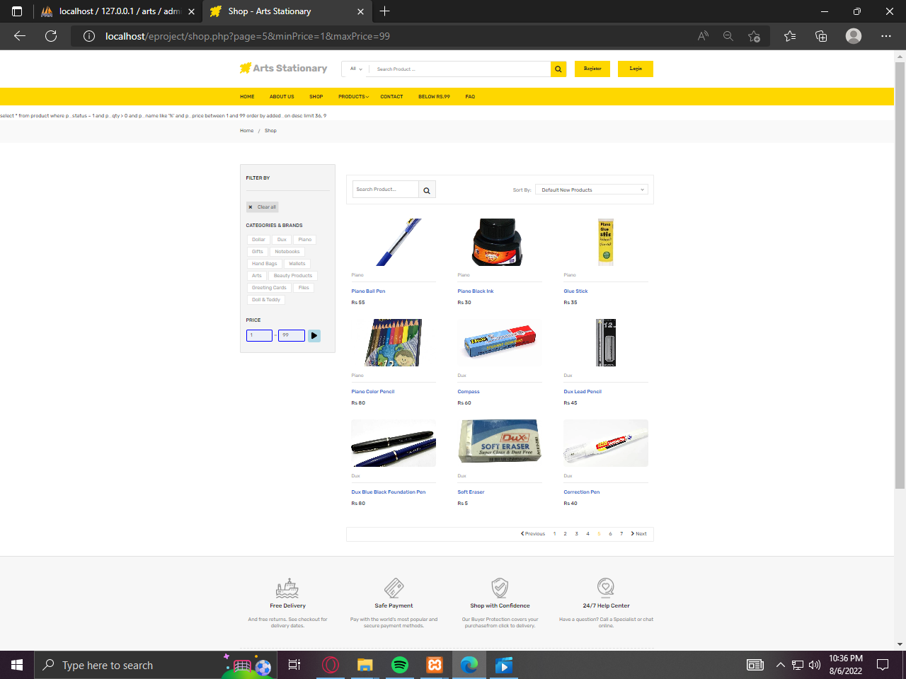

***FAQ PAGE***

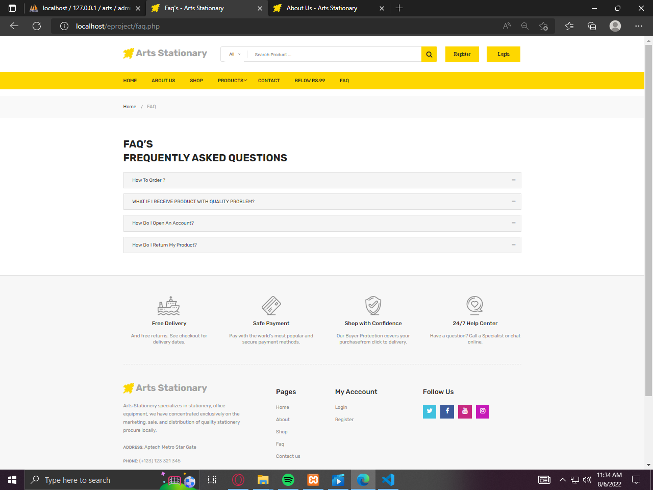

***REGISTRATION PAGE***

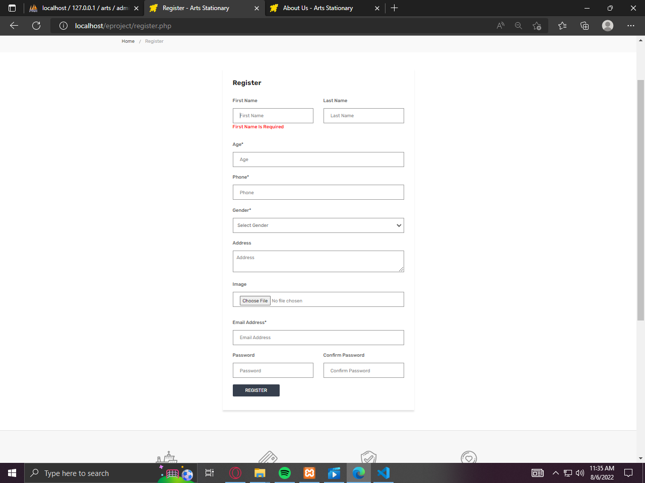

***LOGIN PAGE***

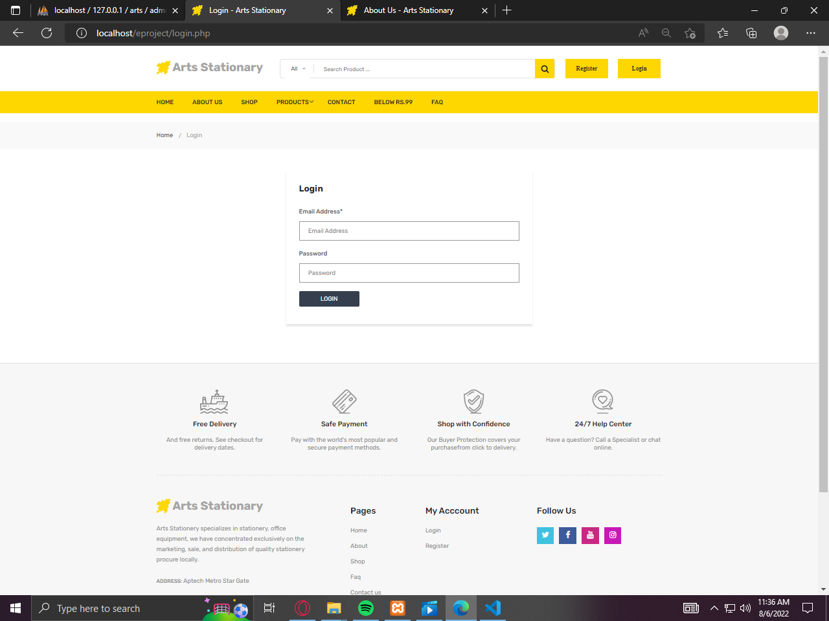

***ADMIN LOGIN PAGE***

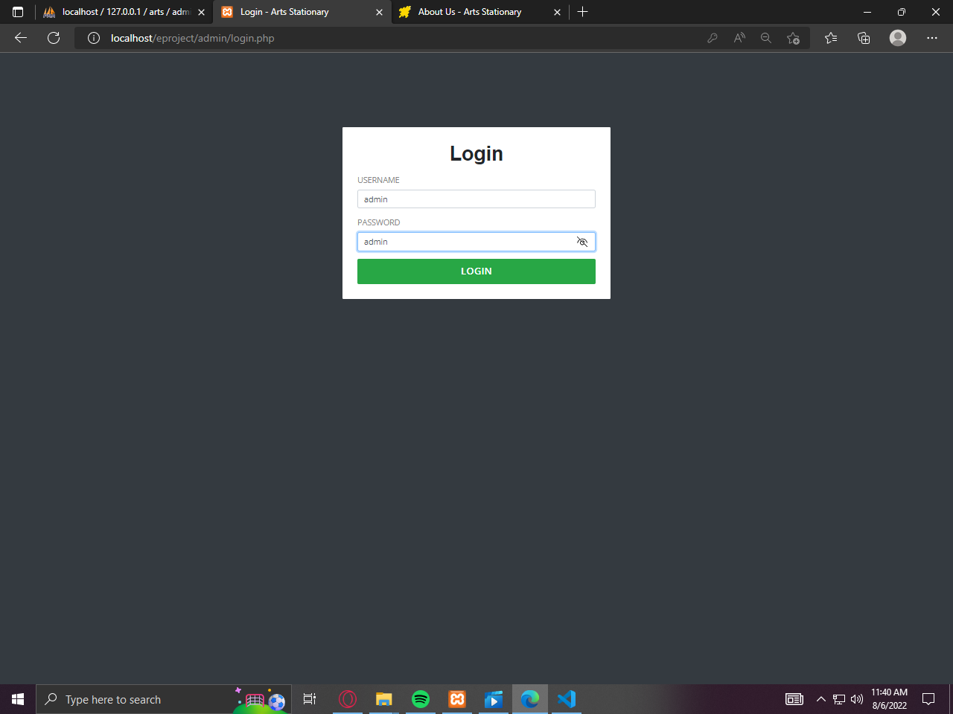

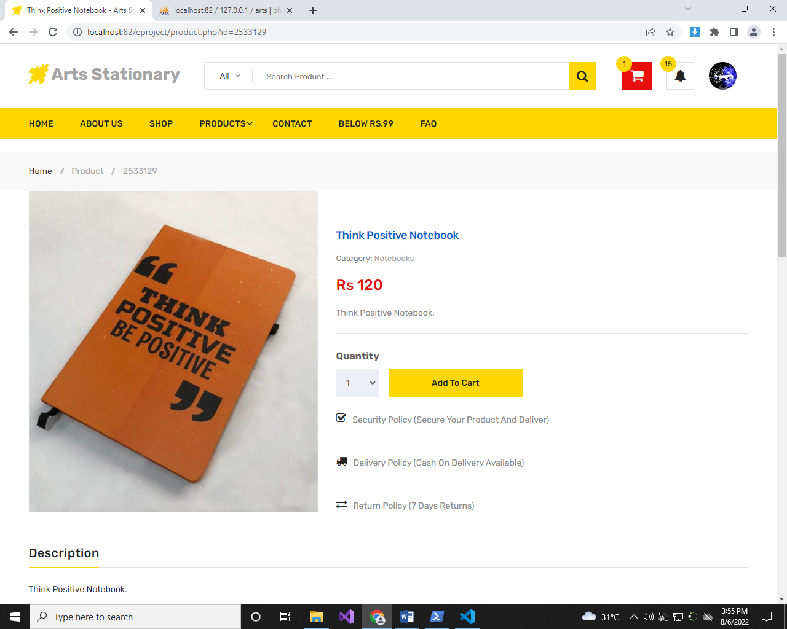***ADD TO CART***

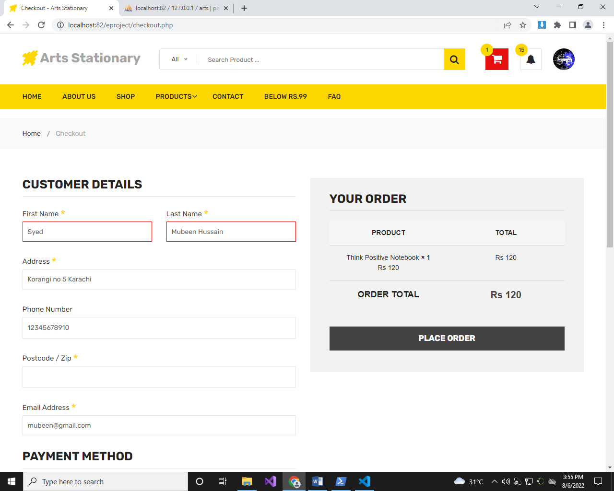***CHECKOUT PAGE***

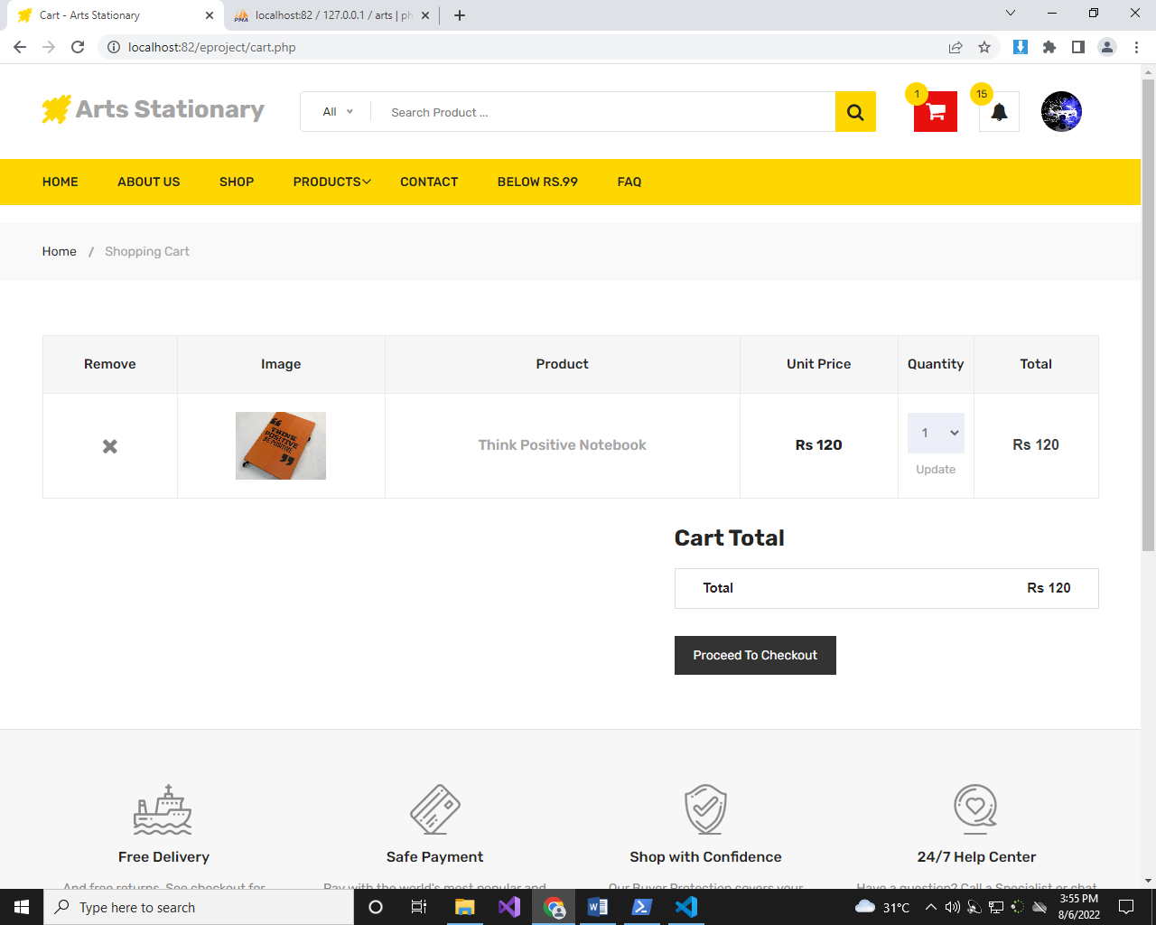***ADD TO CART PAGE***

*****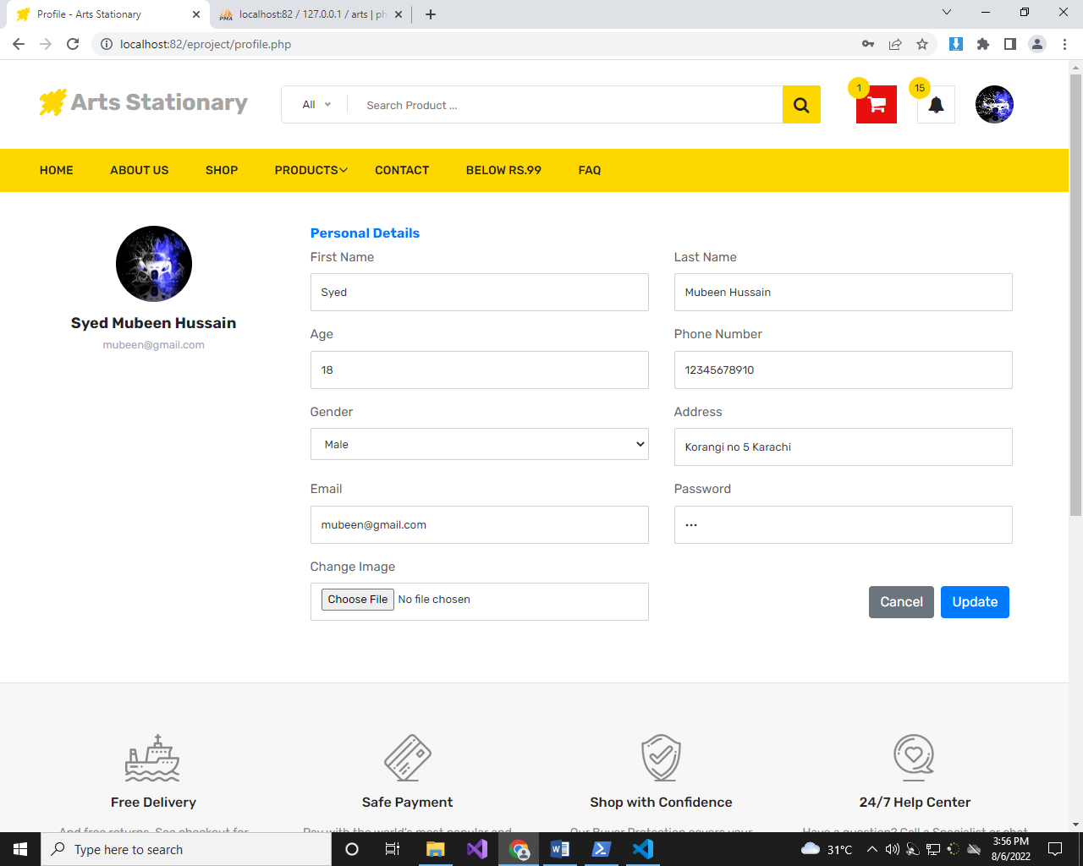USER PROFILE PAGE***

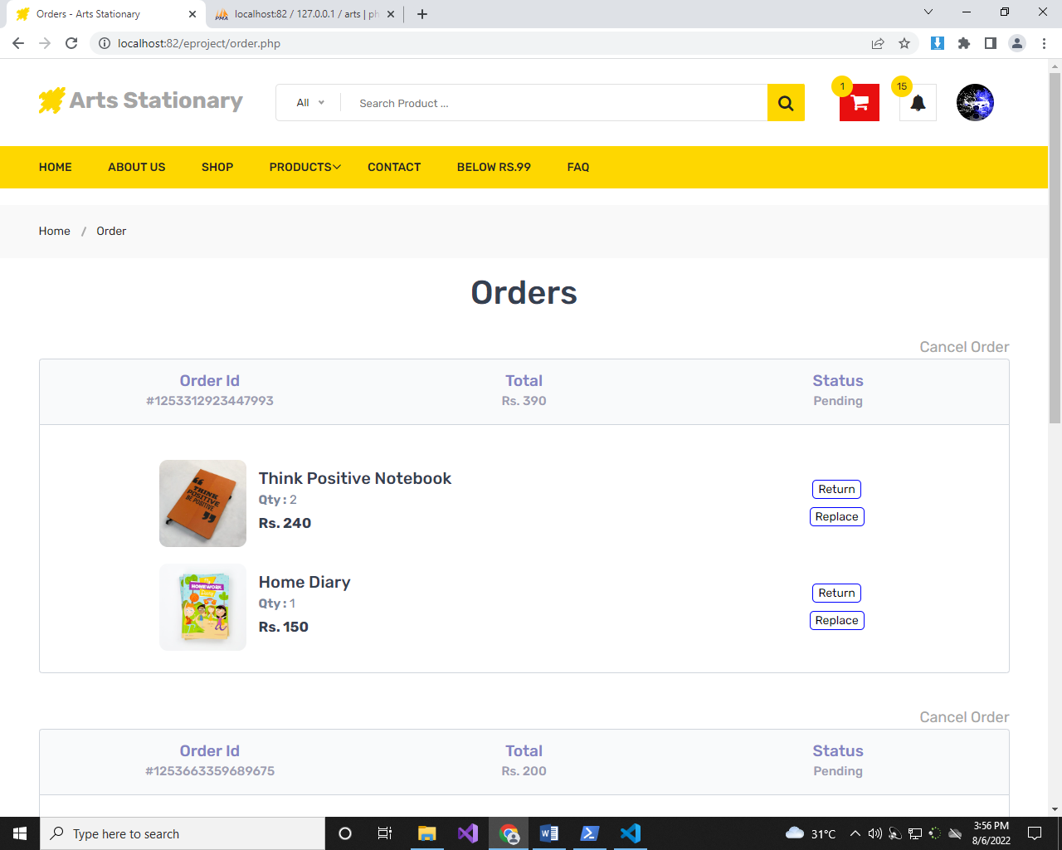***ORDER PAGE***

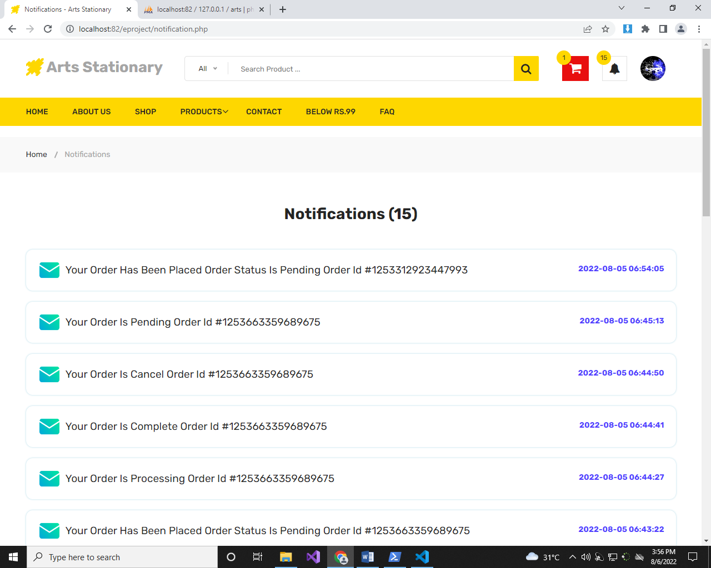***ORDER NOTIFICATION PAGE***

*****ADMIN DASHBOARD***

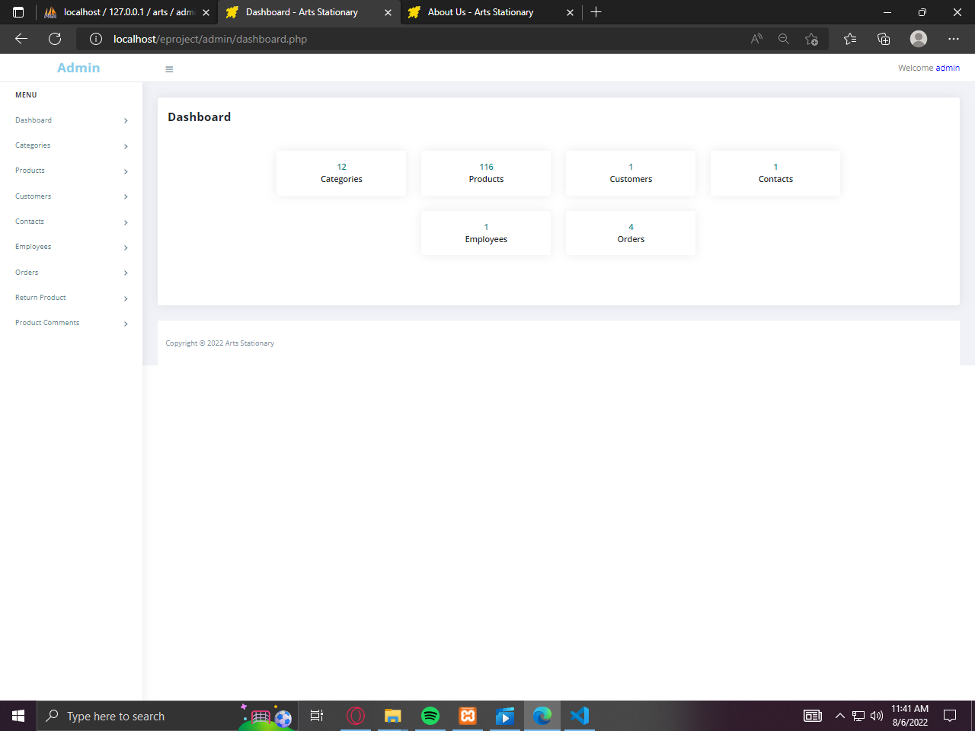

***CATEGORY PAGE***

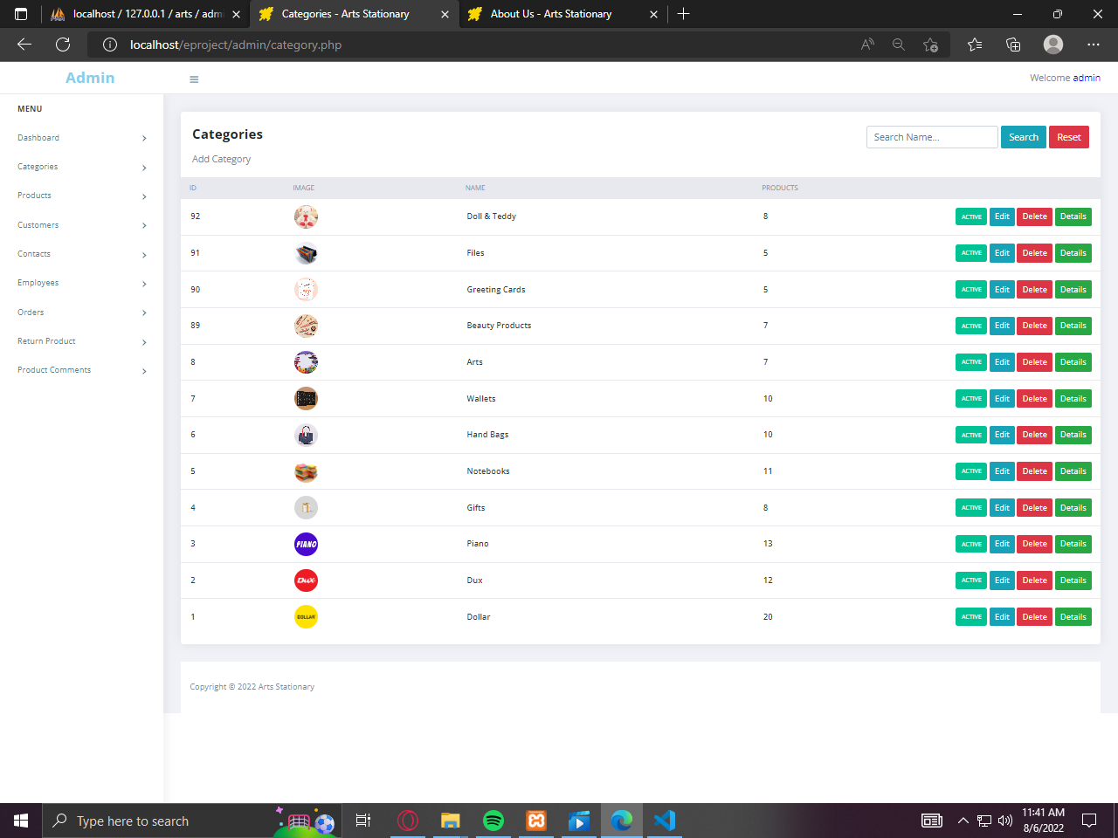

***PRODUCT PAGE***

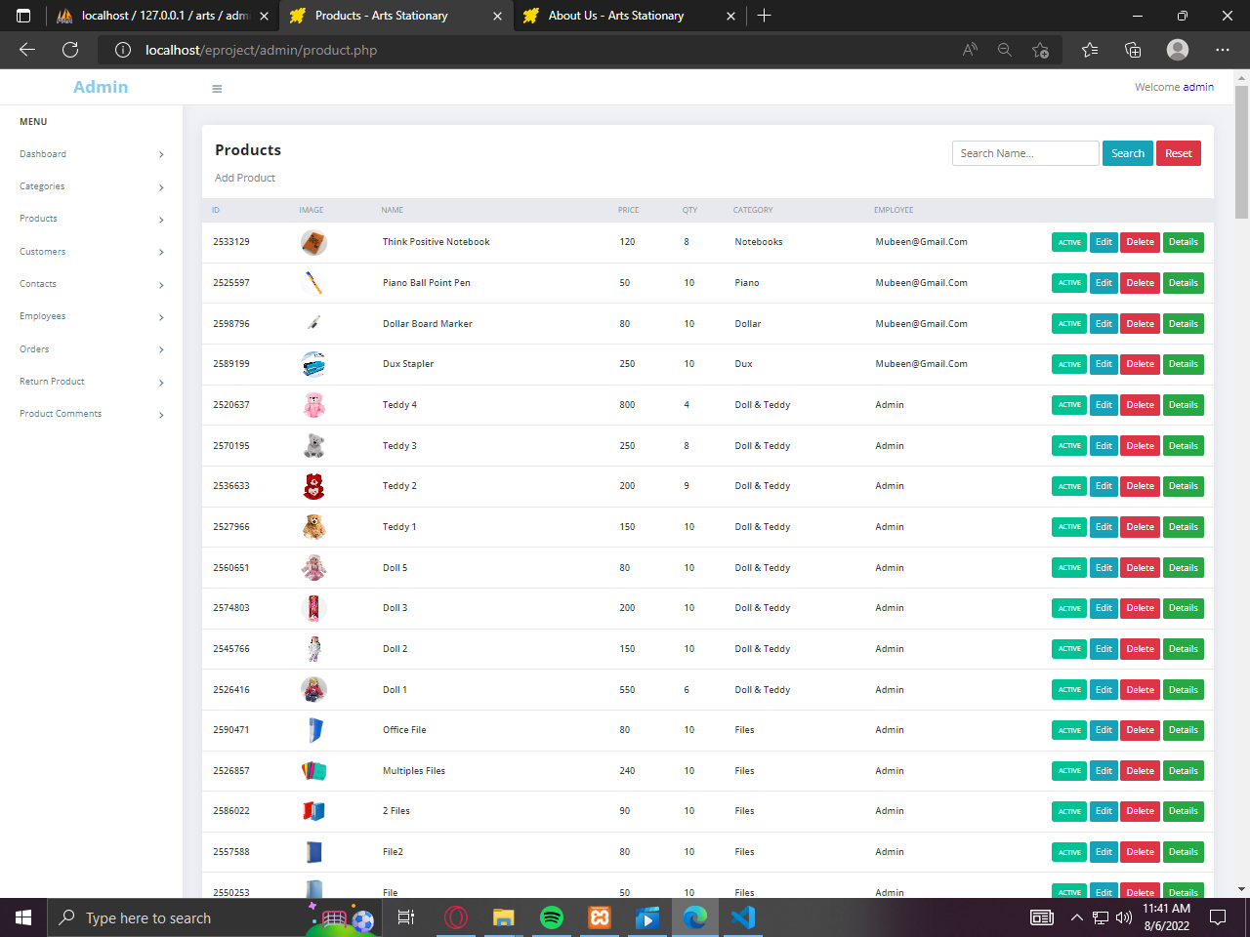

***ADD CUSTOMER PAGE***

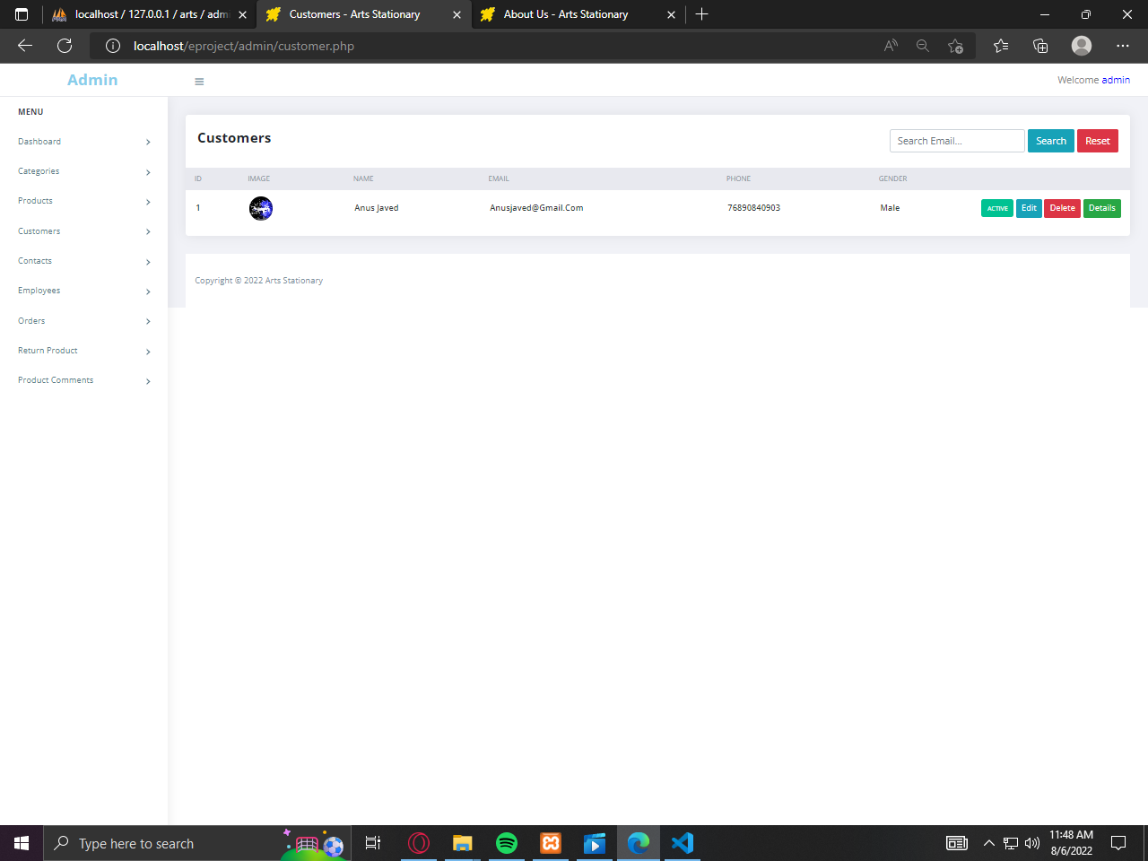

***ADD EMPLOYEES PAGE***

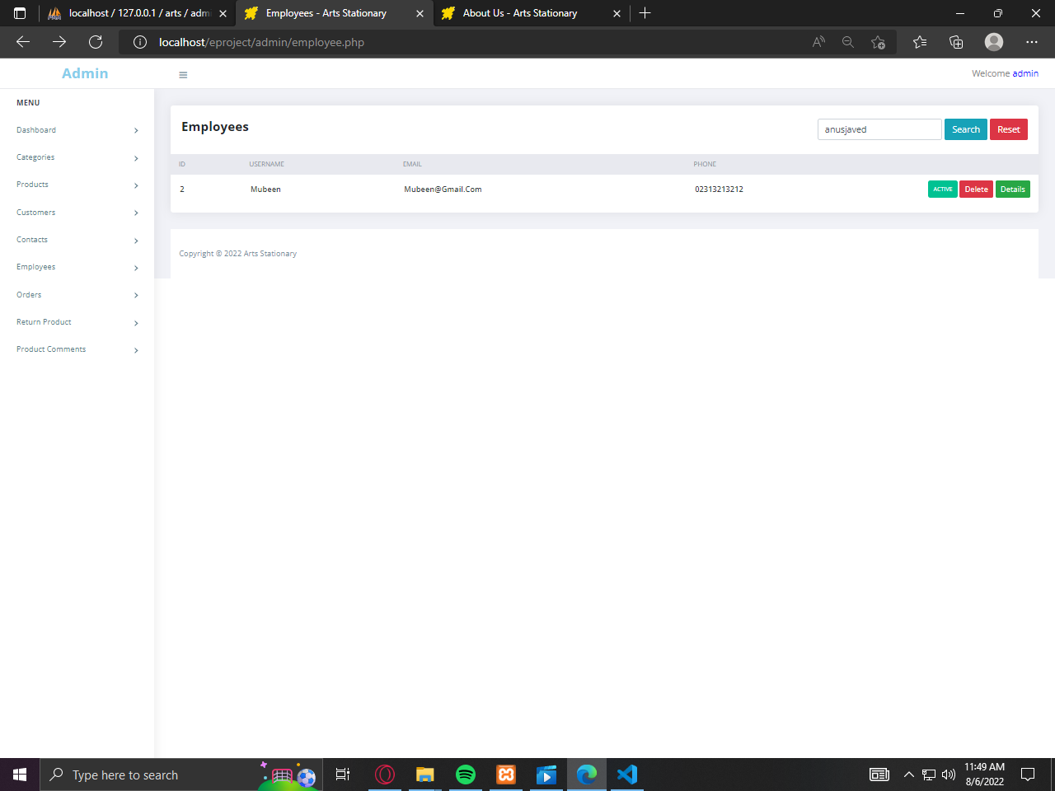

*****ADMIN’S ORDER PAGE***

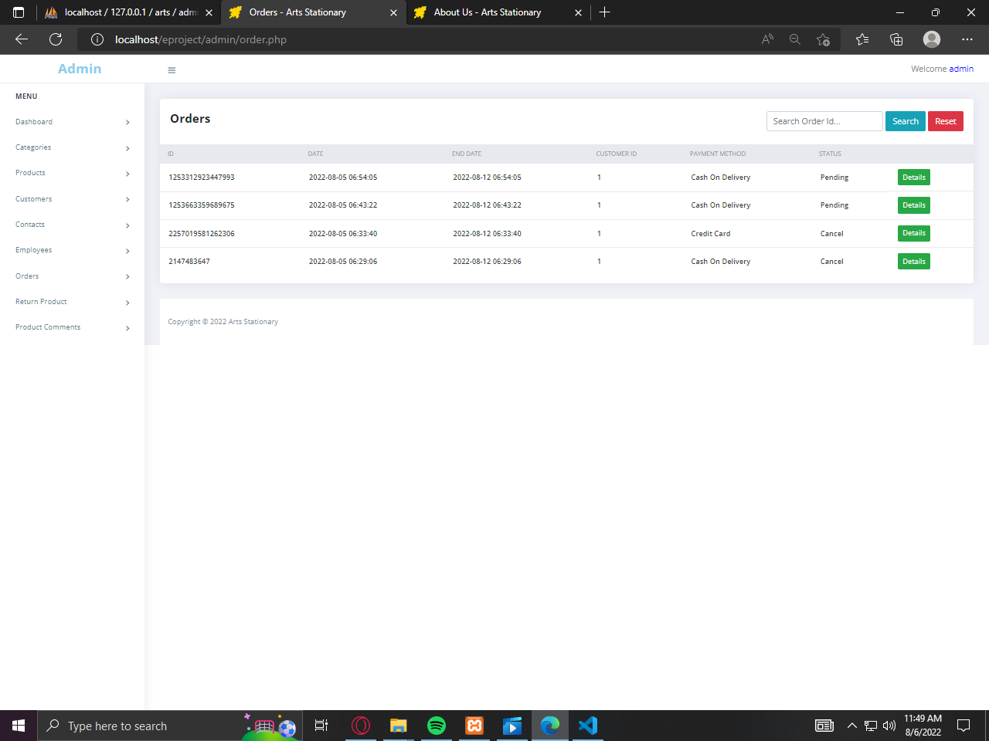

***RETURN PRODUCTS PAGE***

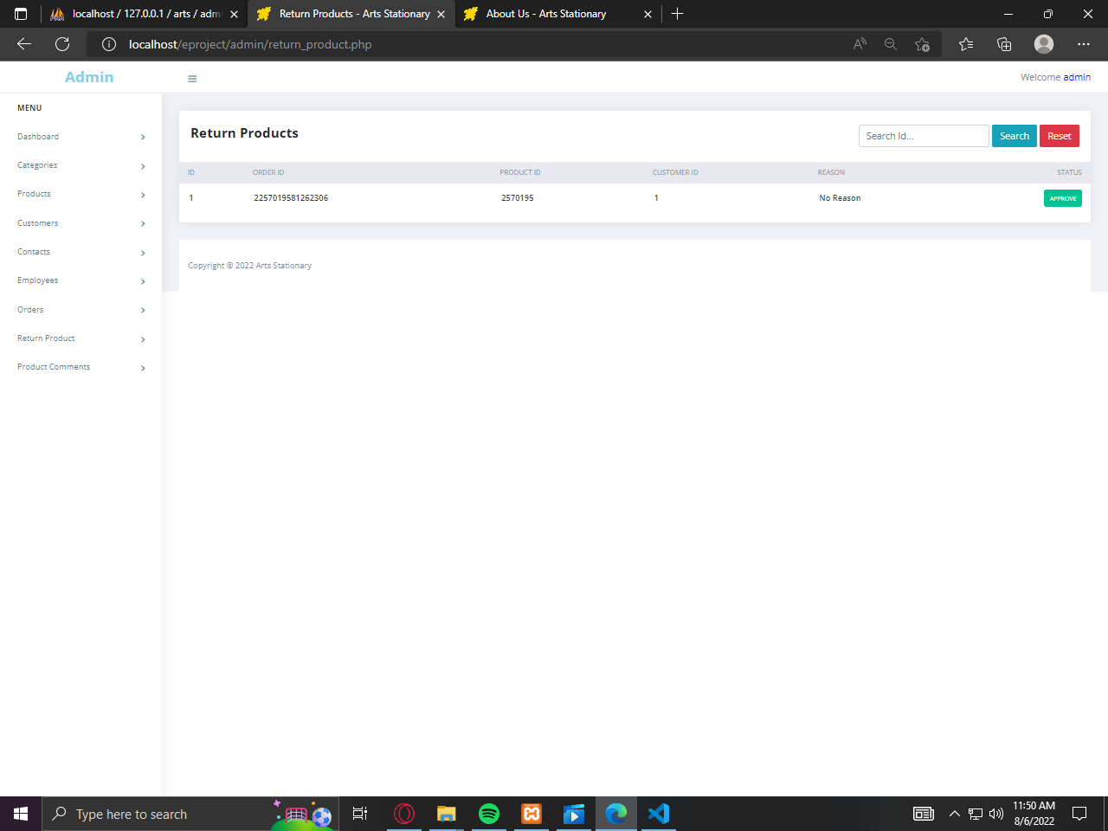

***PRODUCT COMMENT PAGE***

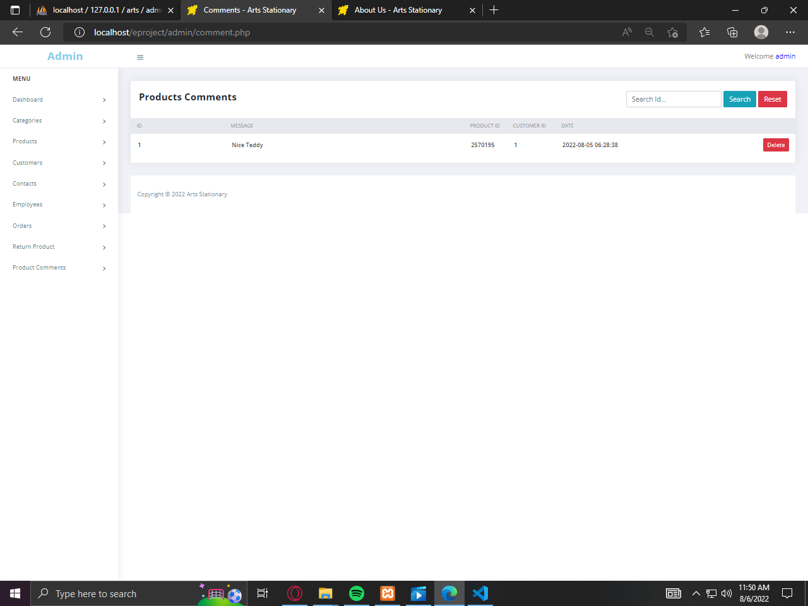

***ADMIN REGISTRATION PAGE***

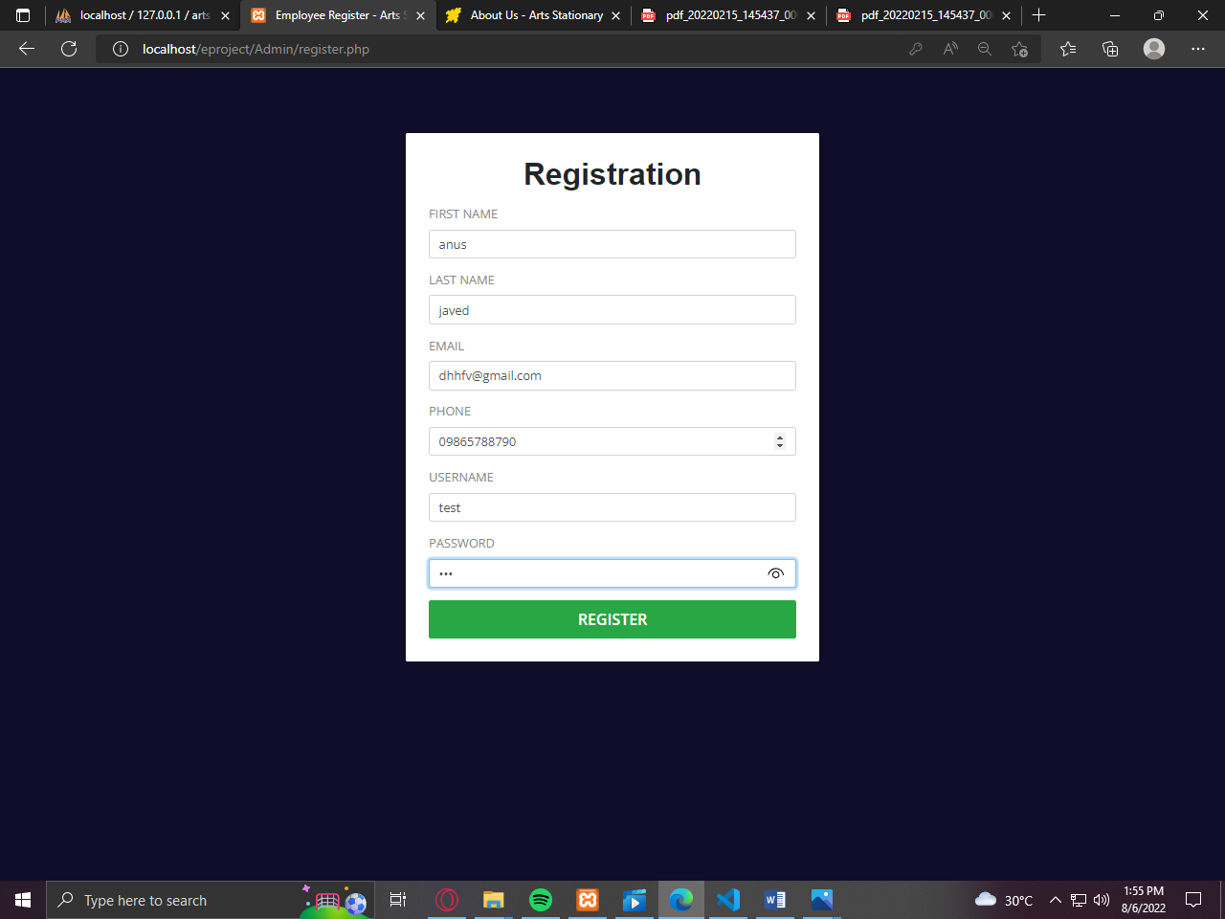

***ADMIN LOGOUT PAGE***

